Nama : Muhammad Lintang Pamungkas

NIM : 210103028

Kelas : TI 21A1

Bagian : UPDATE

1. **Alter**
2. Add

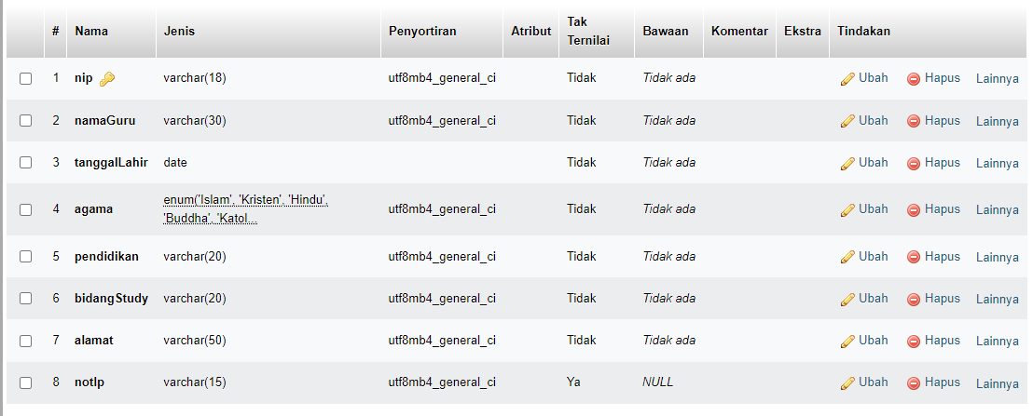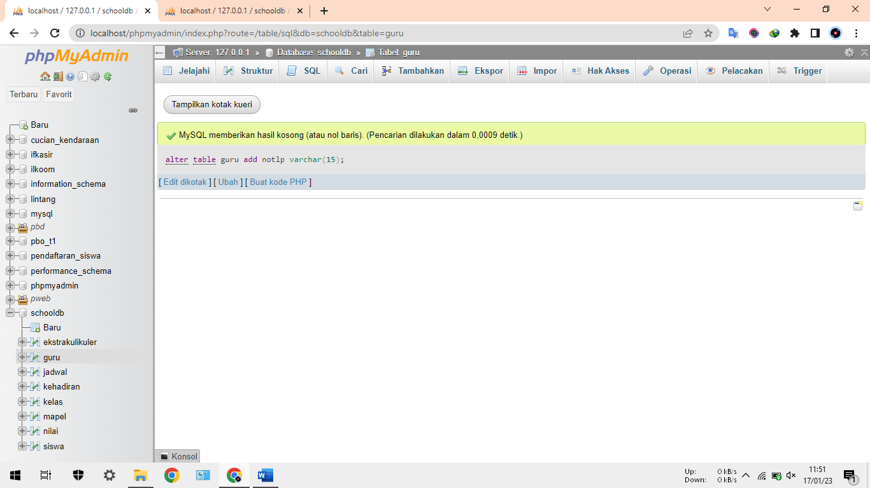ALTER TABLE guru ADD notlp varchar(15);

1. Change

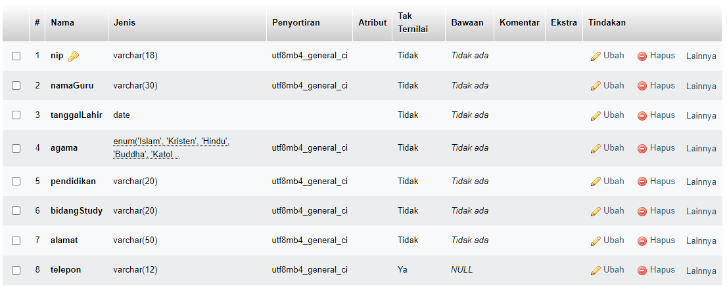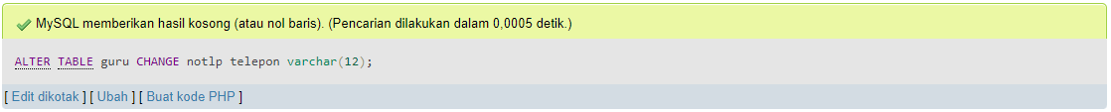ALTER TABLE guru CHANGE notlp telepon varchar(12);

1. Modify

ALTER TABLE guru MODIFY telepon varchar(20);

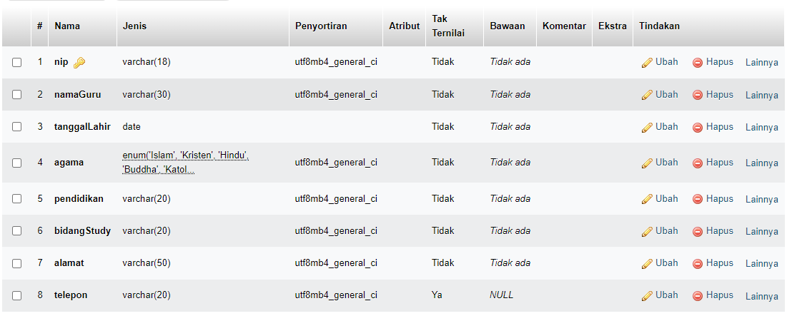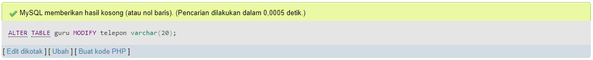

1. Rename

ALTER TABLE guru RENAME lintang_guru;

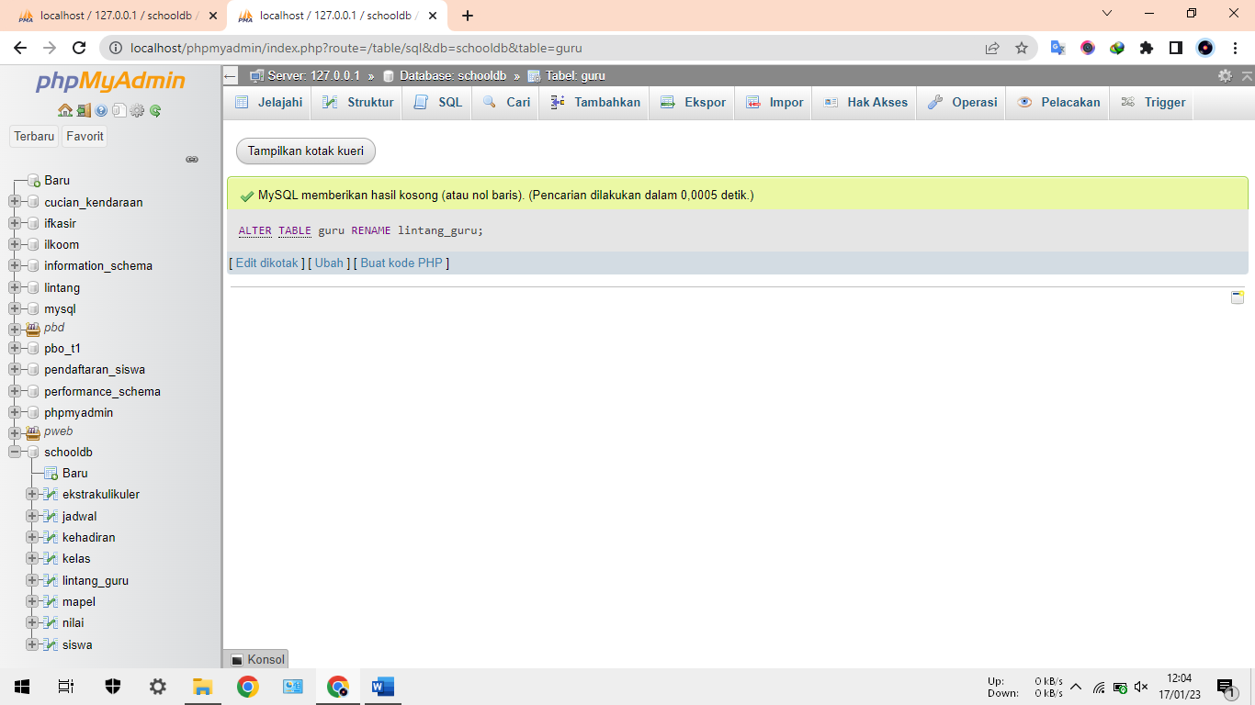

1. Drop

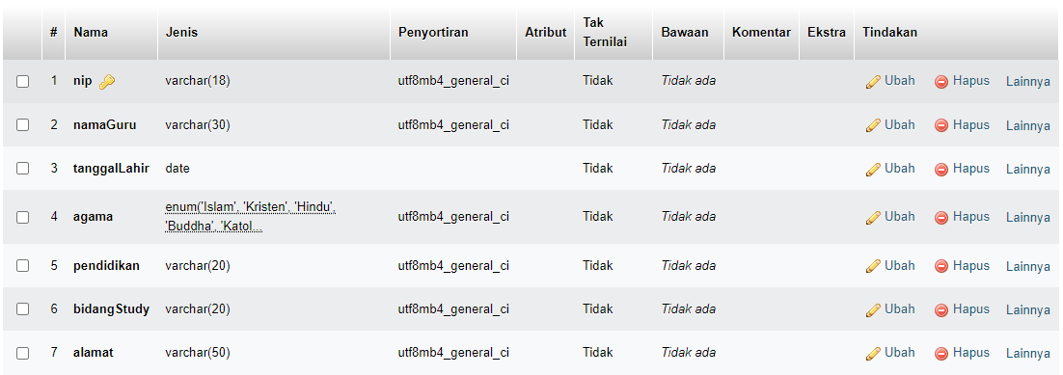ALTER TABLE lintang_guru drop telepon;

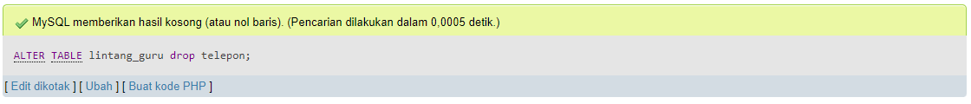

1. **Update**
2. Update semua record

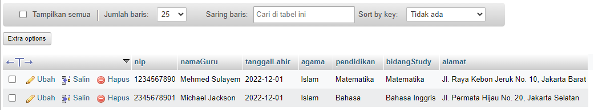UPDATE lintang_guru SET agama=islam;

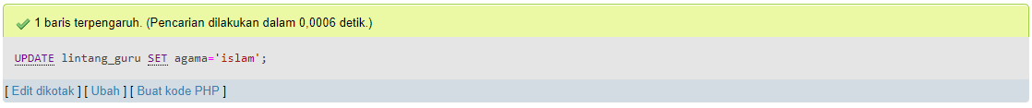

1. Update salah satu guru

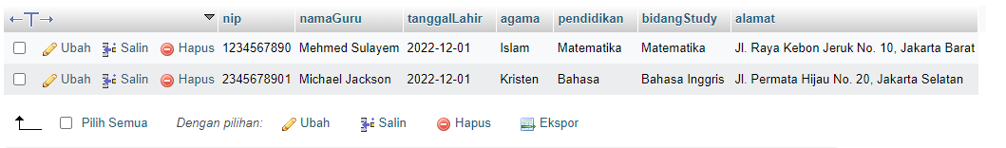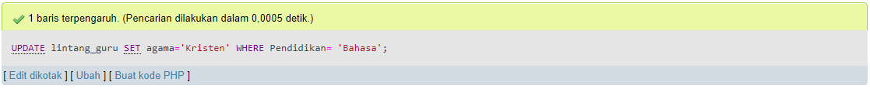UPDATE lintang_guru SET agama=’Kristen’ WHERE Pendidikan= ‘Bahasa’;

1. **Join**
2. Inner join

SELECT guru.nip, guru.namaGuru, guru.pendidikan, guru.alamat FROM lintang_guru as guru INNER JOIN jadwal as j WHERE guru.nip = j.nip;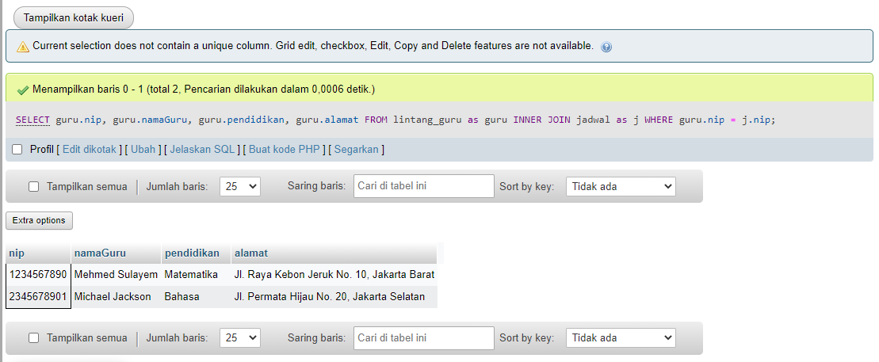

1. Left join

SELECT guru.nip, guru.namaGuru, guru.pendidikan, jadwal.kodeMapel, jadwal.kodeKelas FROM lintang_guru as guru LEFT JOIN jadwal as jadwal ON (guru.nip = jadwal.nip)

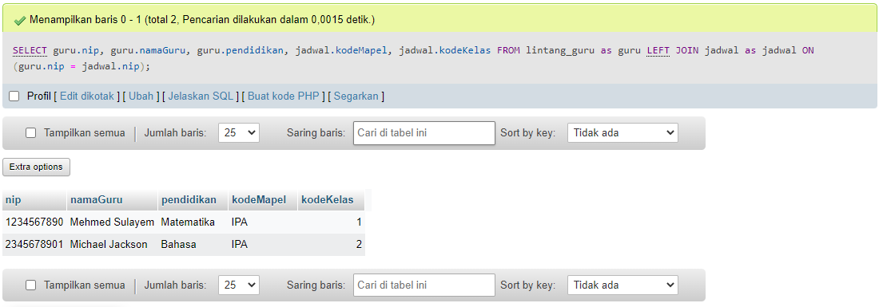

1. Right join

SELECT guru.nip, guru.namaGuru, guru.pendidikan, jadwal.kodeMapel, jadwal.kodeKelas FROM lintang_guru as guru RIGHT JOIN jadwal as jadwal ON (guru.nip = jadwal.nip);

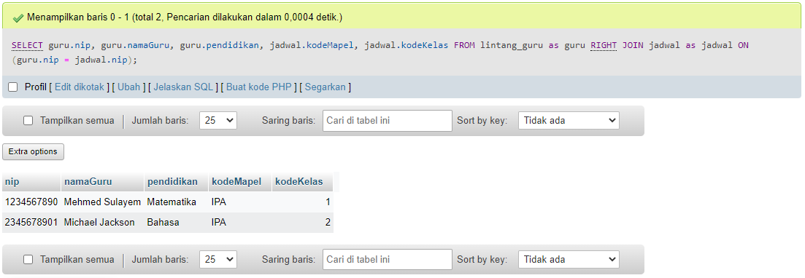

1. **Alias**

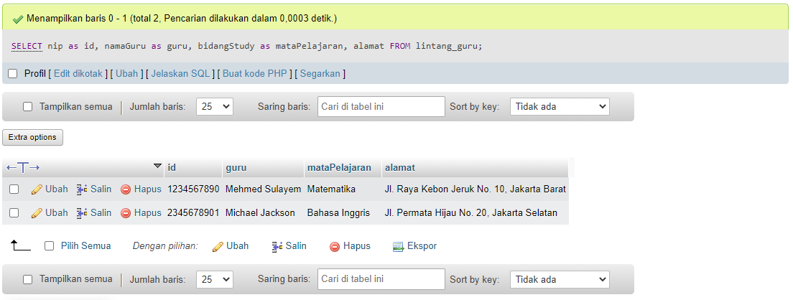SELECT nip as id, namaGuru as guru, bidangStudy as mataPelajaran, alamat FROM lintang_guru;

1. **Where**

SELECT * FROM lintang_guru where agama='islam';

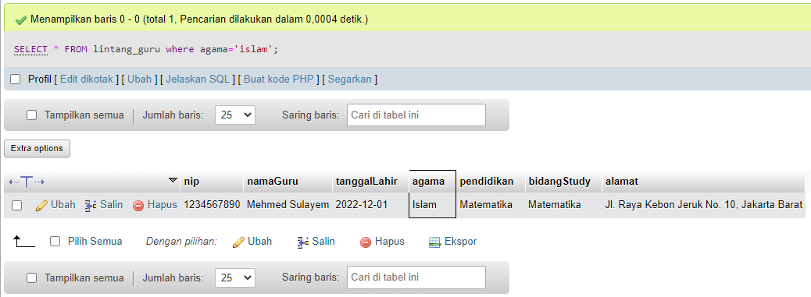

1. **Query dengan agregasi**
2. Sum

SELECT SUM(`siswa_terdaftar`) as 'TotalSiswa' FROM ekstrakulikuler; 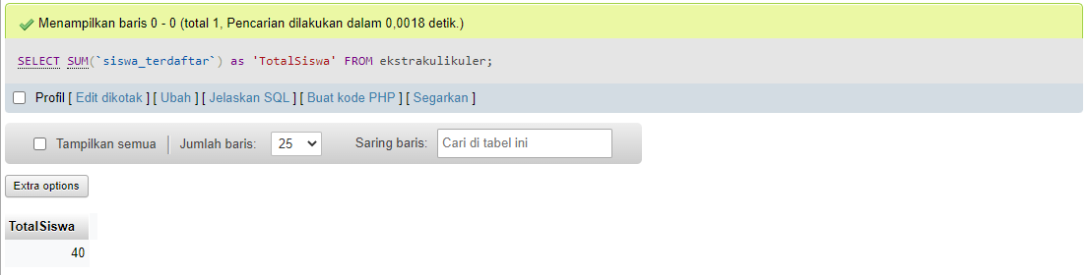

1. Count

SELECT COUNT(`nama_ekskul`) as jumlah_ekstrakulikuler FROM ekstrakulikuler;

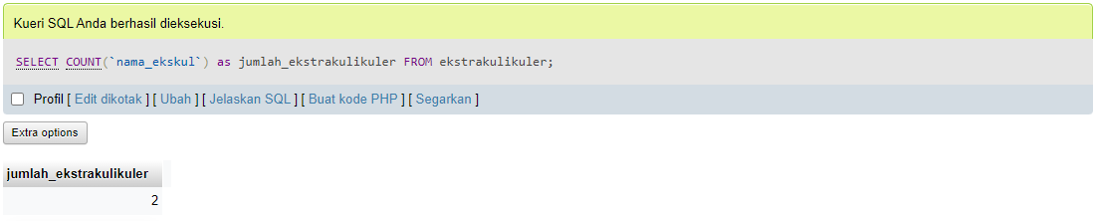

1. Average

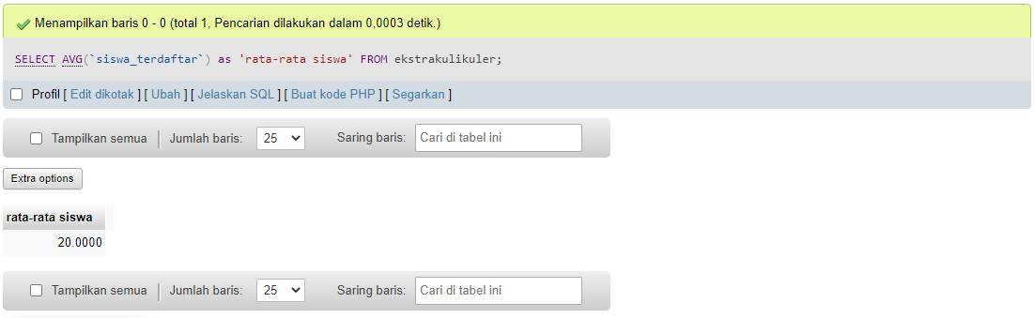SELECT AVG(`siswa_terdaftar`) as 'rata-rata siswa' FROM ekstrakulikuler;

1. Max

SELECT MAX(`siswa_terdaftar`) as 'siswa terbanyak di ekskul' FROM ekstrakulikuler;

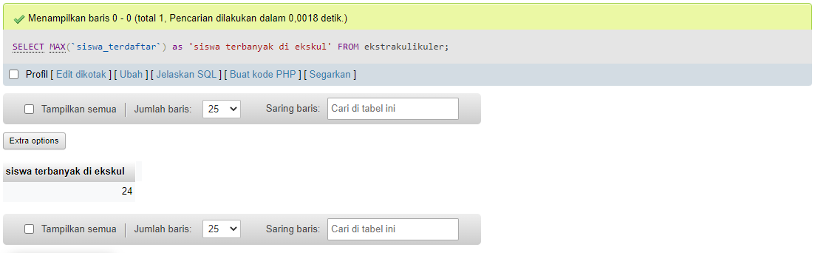

1. Min

SELECT MIN(`siswa_terdaftar`) as 'siswasedikitdiekskul' FROM ekstrakulikuler; 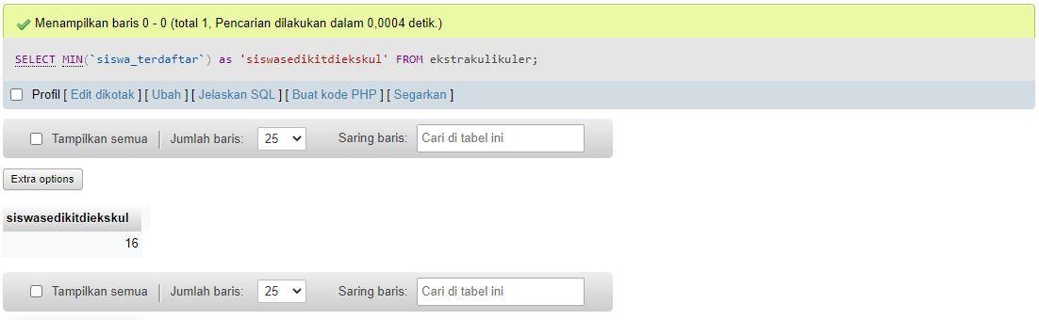

1. **Query bersarang**

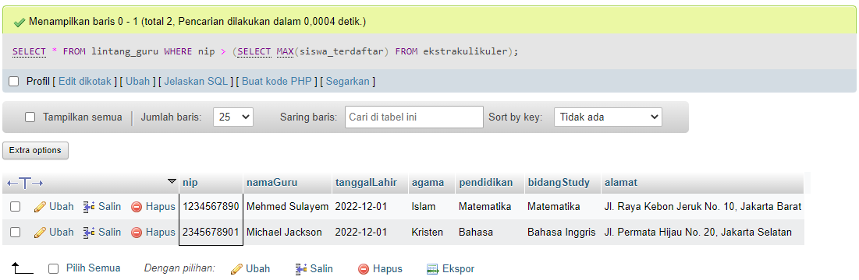SELECT * FROM lintang_guru WHERE nip > (SELECT MAX(siswa_terdaftar) FROM ekstrakulikuler);

SELECT lg.namaGuru as guru, (SELECT jd.kodeMapel FROM jadwal as jd WHERE jd.nip = lg.nip) as lg, lg.alamat as 'rumah' FROM lintang_guru as lg;

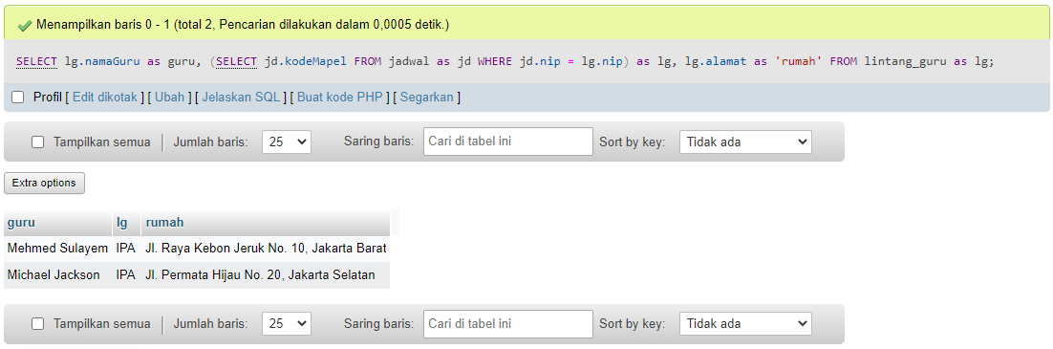

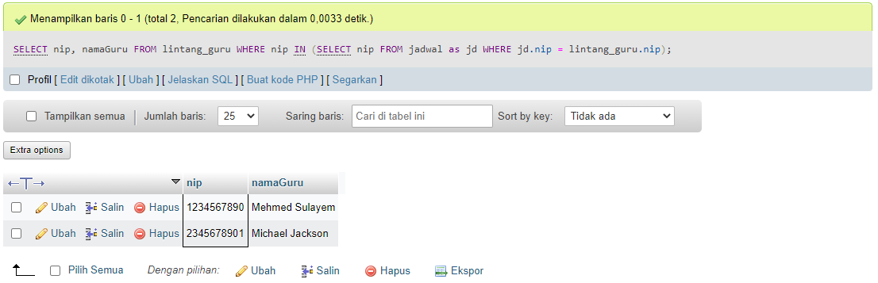SELECT nip, namaGuru FROM lintang_guru WHERE nip IN (SELECT nip FROM jadwal as jd WHERE jd.nip = lintang_guru.nip);

1. **Case**

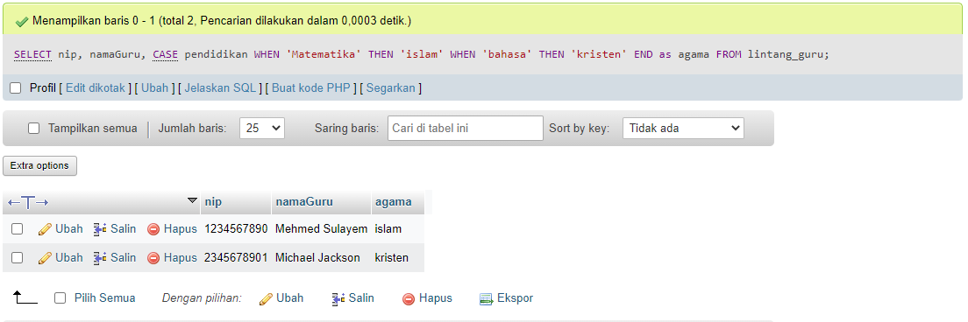SELECT nip, namaGuru, CASE pendidikan WHEN 'Matematika' THEN 'islam' WHEN 'bahasa' THEN 'kristen' END as agama FROM lintang_guru;